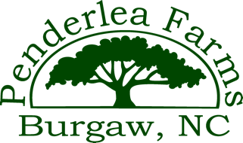 Retail Availability/Price List
Live Oaks
Container Size | Retail Price
3 Gallon | $35.00
7 Gallon | $75.00
15 Gallon | $175.00
25 Gallon | $250.00
45 Gallon | $500.00
65 Gallon | $750.00
100 Gallon | $1400.00
168 Gallon | $1600.00
** Field Grown larger trees are priced individually by Caliper size ($200/inch)

Other Species Pricing
Swamp Chestnuts
Container Size | Retail Price
3 Gallon | 13.00
7 Gallon | $32.00
15 Gallon | $70.00

Swamp White Oak
Container Size | Retail Price
3 Gallon | $13.00
7 Gallon | $32.00

Bald Cypress
Container Size | Retail Price
65 Gallon | $300.00 (Fire Sale Price)

Green Giants
Container Size | Retail Price
65 Gallon | $175.00

Longleaf Pine
Container Size | Retail Price
25 Gallon | $150.00

Wax Myrtles
Container Size | Retail Price
45 Gallon | $200

